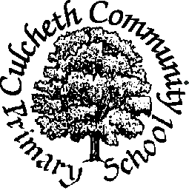
Where Learning is Fun!

Culcheth Community Primary School

Marking and Target setting Policy 2020-2021

This policy has been discussed and agreed upon by the whole staff. It outlines the nature of marking in our school.

Aims

Working in partnership with children and parents it is our aim to continuously move children’s learning on through effective, meaningful marking and personalised targets.

Marking

-All children’s work is regularly marked and initialled with a green pen.
-Children are given daily opportunities to respond to the teachers marking ‘Fix-It’ time. Children use a red pen to do this.
-Teachers build in time to revisit the improvements made by the children during ‘Fix-It’ time- this is done during the start of a lesson or during ‘Morning Activity’ time from 8.40-9am
-Every effort is made to give verbal feedback, encouragement and praise during a session.
- Children are encouraged to add any written corrections within the margin of their book to maintain ‘Perfect Presentation’.
-Teachers within both key stages use a selection of age appropriate marking symbols (see attached sheet).
-TI- Teacher Input GW- Guided Work/writing these abbreviations indicate that the children have been given extra input and completed a guided work session with the teacher/teacher assistant.

Feedback in marking

- Where it is impossible for an adult to give specific feedback during a session then written comments should be given that require a response or action that can be completed in the morning ‘Fix-it Time’ Children respond to comments in red pen.
- Where praise is given in marking, it must be specific and relate to progress rather than ability. Praise must only be given for meaningful success that is credible.
- It is essential that the impact of marking can be seen in the children’s work and future work.
- In maths occasionally the children will be set challenges to answer questions in a different context.

