

Culcheth Primary School
Attendance Policy
Pupils 2025-2026

Date policy last reviewed: | September 2025

Last updated: September 2025

School attendance matters

Missing a few days of school may not seem important, but research shows that it has a significant impact on children’s learning. Children who miss a substantial amount of school can fall behind their peers, and struggle to catch up.

- Every child has a right to education and to have the best possible life chances. By attending school daily and on time they learn the importance of commitment and being punctual, a life skill that will serve them well as they grow into the next generation of working citizens.

- It is hard to catch up enough on the work that is missed due to absence, therefore it will be hard for children to achieve their best results if there are gaps in their learning.

- Not being at school regularly also has a negative effect on the social aspects of school. It is hard for children to build and maintain good friendships if they are not in school regularly.

- School is open from 8:35am to 8:45am to ensure that children have the opportunity to be in school on time. 5 minutes late each day can have an accumulative impact on your child's education.
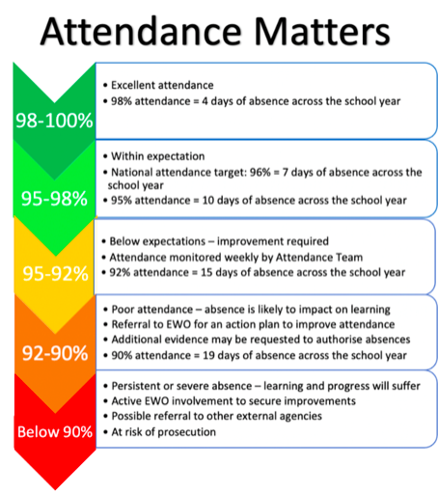
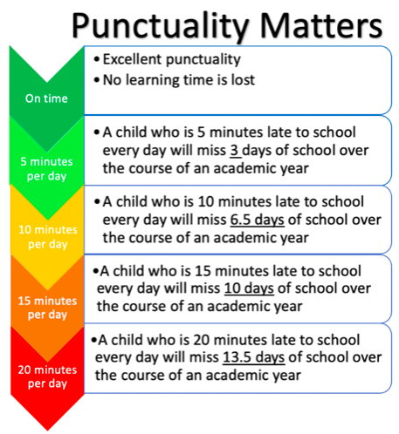

Parent/Carer Responsibilities


- Parents/carers have a legal duty as well as a moral obligation to ensure that children of compulsory school age attend on a regular and full-time basis.

- We encourage parents and carers to send their children to school whenever possible, however if they have sickness or diarrhoea, please keep them at home for 48 hours of being symptom free. If a child is off for a week, we would expect them to have seen a doctor and may ask for evidence of an appointment or medicine prescription. Medications can be administered in school to enable children to attend, please come to the school office to arrange this.

- Parents/carers should ensure that if their child is to be absent from school for any unavoidable reason (such as sickness) they should contact the school as soon as possible and before 8.55am on the first morning of absence. This may be done by phone, email or in person. School should then be kept informed on a day-to-day basis.

- You are encouraged to make children’s medical appointments outside of school hours, if possible. If this is not possible, we ask that parents provide the school with evidence of appointments (at least 48 hours’ notice where possible) in order that we can discuss with you.

- Culcheth Primary School carries out absent coding in line with the Local Authority (LA) guidance. (Should parents/carers fail to provide a satisfactory reason for their child's absence the school will record such absence as unauthorised.) Unacceptable reasons for absence include holidays, shopping and birthdays.

- Parents/carers should ensure that their child arrives at school in time for the start of the school day (8.45am.). If a child is later than 8.45am they should report directly to the school office.

- If a child is ill in the morning but feels better later, parents are welcome to bring them into school. Additionally, if a parent feels that their child is ill but can manage a morning, but not a full day, they can bring them in for the morning and collect at lunchtime. Calpol and ibuprofen can be administered by the school office if an adult signs a form to authorise this.

- Requests for leave should be made at least two school weeks in advance and will be considered on an individual basis by the Head Teacher (or in their absence by the Deputy Head and a member of the Governing Body) following the Local Authority’s attendance guidance. Parents/carers are advised not to make any arrangements until the request for leave of absence has been considered.

The following may be examples of exceptional circumstances:
- To allow a pupil to return to their country of origin for family, religious or cultural reasons.
- To partake in religious festivals.
- A family member is seriously ill.
- Leave of absence for children of serving members of the Armed Forces.
- Attendance at an examination, for example a music examination.

The following examples are deemed not to be exceptional circumstances:
- A cost differential.
- One or both parent(s) / carer(s) having inflexible leave allocation throughout the year including when this has been confirmed by their employer.
- A surprise holiday booked as a gift.
- Attendance or participation of a family wedding, including that of the child’s parents.
- A new holiday booking as a result of a previous cancellation irrespective of the reason provided.
- Attendance of grassroots / community club tours, e.g. sporting or music.

School Responsibilities

- The school will record and monitor attendance in accordance both with the statutory requirements and with the principle that regular, uninterrupted attendance is vital to a child's educational progress.

- Registers will be called twice daily at the start of each morning and afternoon session and will be kept open until 9.30am in the morning and 1.30pm in the afternoon. If a child arrives before the closure of the register they will be marked ‘L’ for late arrival. Any child arriving after the register has been called will be recorded as a ‘U’ for unauthorised absence for that session. If a child arrives after the register has closed but their parent/carer provides them with a note detailing a reason acceptable to the school, they will be marked ‘C’ as an authorised absence for that session.

- If they are late and fail to provide an acceptable reason they will be marked as an unauthorised absence for the whole of that session.

- Teachers will complete registers in accordance with the guidance they have been given. The Head Teacher will inspect registers periodically in order to ensure that they are being satisfactorily maintained and to ensure that any potential attendance difficulties are identified at an early stage.

- Should a class teacher have particular concerns about an individual child's attendance or punctuality the Head Teacher should be informed. The school Office manager will alert the Head Teacher if any child's attendance falls below 95%.

- If a child is absent the class teacher will not enter any code in the register, leaving the office staff to select the correct code for that absence. The office manager will text any parent who has failed to inform the school of the reason for an absence by 9.10am, then follow with a safeguarding text if no contact has been made by 9.30am. If there is still no contact, a phone call will be made by 10am.

- If we do not have regular contact from parents of an absent child, this will become a safeguarding issue. We will call all contacts on our lists, and we may carry out a home visit for a welfare check.

- Where children have an illness that means they will be away from school for over five days, the school will, if requested, send material home so that they can keep up with school work.

- The Head Teacher will regularly review attendance data and will use this data during meetings with the school's Attendance Officer and Governing Body. These meetings will agree on attendance thresholds and targets and will identify respective tasks and follow-up actions for both the school and attendance service.

- The school will employ a number of strategies to promote regular, punctual attendance:

  - The Head Teacher and class teachers will communicate regularly with parents/carers about attendance (primarily via the weekly newsletter)

  - Parents will have access to support where appropriate.

  - If all pupils are on time, the whole class is rewarded with 5 Dojos per child.

- The class with the best attendance each week will receive an extra playtime.

- The class with the best attendance over a term will receive a rewards afternoon.

- All pupils in classes with 100% attendance in a week will get a small reward (eg Haribos)

Working together to improve attendance

Expect

Aspire to high standards of attendance from all pupils and parent/carers and build a culture where all can, and want to, be in school and ready to learn by prioritising attendance improvement across the school.

Monitor

Rigorously use attendance data to identify patterns of poor attendance (at individual and cohort level) as soon as possible so all parties can work together to resolve them before they become entrenched.

Listen and understand

When a pattern is spotted, discuss with pupils and parent/carers to listen to and understand barriers to attendance and agree how all partners can work together to resolve them.

Facilitate support

Remove barriers in school and help pupils and parent/carers to access the support they need to overcome the barriers outside of school. This might include an early help or whole family plan where absence is a symptom of wider issues.

Formalise support

Where absence persists and voluntary support is not working or not being engaged with, partners should work together to explain the consequences clearly and ensure support is also in place to enable families to respond. Depending on the circumstances this may include formalising support through an attendance contract or education supervision order.

Enforce

Where all other avenues have been exhausted and support is not working or not being engaged with, enforce attendance through statutory intervention: a penalty notice in line with the National Framework or prosecution to protect the pupil’s right to an education.

