**Reception**

**PROMPT sheet**

**0/1 Recognise numerals 1 to 5**

|  |  |  |
| --- | --- | --- |
| https://edc2.healthtap.com/ht-staging/user_answer/avatars/97065/large/open-uri20120120-29634-1lacpkx.jpeg?1386551771 |  | http://files.doobybrain.com/wp-content/uploads/2009/02/cookie-monster-cupcake.jpg |
| http://www.coloringmates.com/wp-content/uploads/Peace-Coloring-Pages6.gif |  | http://www.impkids.co.uk/userfiles/images/sys/products/Twister_stripe_socks_52346.jpeg |
| http://www.drclay.com/wp-content/uploads/2011/09/3-fingers.jpg |  | http://i1.ytimg.com/vi/ooDVYDuFqEA/hqdefault.jpg |
| http://dedalvs.conlang.org/images/slipa/handshape/4.gif |  | http://v5.bearskinrug.co.uk/_articles/2010/07/22/mental_notes/mn_4clubs.jpg |
| https://it.uoregon.edu/sites/default/files/200px-5fingers_icoline.svg_.png |  | http://www.balloonhq.com/faq/balloonware/clip_art/collection1/C265x315.gif |

**0/2 Counting objects**

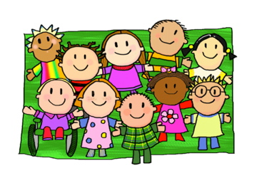

Say and touch the number as you count



**0/3 Counting up to 10**

|  |  |  |
| --- | --- | --- |
| http://www.designofsignage.com/application/symbol/hands/image/600x600/hand-6-six.jpg |  | http://www.clker.com/cliparts/Y/O/V/X/F/D/dice-6-hi.png |
| http://www.designofsignage.com/application/symbol/hands/image/600x600/hand-7-seven.jpg |  | http://ideaglow.wpengine.com/wp-content/uploads/2013/08/7-with-baby-chicks.jpg |
| http://www.designofsignage.com/application/symbol/hands/image/600x600/hand-8-eight.jpg |  | http://4.bp.blogspot.com/-STLtk9GwBMI/USzvchhUAoI/AAAAAAAACHY/ugYAs_JXLew/s1600/octopus.jpg |
| http://www.designofsignage.com/application/symbol/hands/image/600x600/hand-9-nine.jpg |  | http://upload.wikimedia.org/wikipedia/commons/9/9d/9ball_rack_2.jpg |
| https://encrypted-tbn3.gstatic.com/images?q=tbn:ANd9GcSo9tplLyYJuPyvd82un7cx5gmdCa1J2-2lBae93WptpyobX8Ms |  | http://metrouk2.files.wordpress.com/2013/11/ad120962802metrochristmases-e1385138135397.jpghttp://metrouk2.files.wordpress.com/2013/11/ad120962802metrochristmases-e1385138135397.jpghttp://metrouk2.files.wordpress.com/2013/11/ad120962802metrochristmases-e1385138135397.jpghttp://metrouk2.files.wordpress.com/2013/11/ad120962802metrochristmases-e1385138135397.jpghttp://metrouk2.files.wordpress.com/2013/11/ad120962802metrochristmases-e1385138135397.jpghttp://metrouk2.files.wordpress.com/2013/11/ad120962802metrochristmases-e1385138135397.jpghttp://metrouk2.files.wordpress.com/2013/11/ad120962802metrochristmases-e1385138135397.jpghttp://metrouk2.files.wordpress.com/2013/11/ad120962802metrochristmases-e1385138135397.jpghttp://metrouk2.files.wordpress.com/2013/11/ad120962802metrochristmases-e1385138135397.jpghttp://metrouk2.files.wordpress.com/2013/11/ad120962802metrochristmases-e1385138135397.jpg |

**0/4 Count from a large group**

Say the number as you count each object

Count and point

Count on from bigger number

To select 6 from this group of children

**6**

**1**

**5**

**2**

**3**

**4**

**0/5 Select the numeral**

**Check!!**

|  |  |  |  |
| --- | --- | --- | --- |
| **3** | http://gitikapartington.files.wordpress.com/2011/12/3-french-hen.jpeg | **9** | http://www.10millionmiles.com/wp-content/uploads/2008/01/9thday.gif |
| **1** | http://www.birdorable.com/blog/img/12days_partridge.jpg | **7** | http://www.hitechanswers.net/wp-content/uploads/2012/12/seven-swans-a-swimming.jpg |
| **2** | http://imgcdn.geocaching.com/cache/d8798a3b-8a3c-4175-9a62-a69b8c3b80a1.gif?rnd=0.7165295 | **6** | http://rlv.zcache.com/6_geese_a_laying_invite-r451b77057bd54e9cb0af1b3e982ba4bb_imtqg_8byvr_512.jpg |
| **5** | http://thesassylibrarian.files.wordpress.com/2011/12/5_fivegoldrings_b.gif | **10** | **http://4.bp.blogspot.com/_2LBhxpmHVIc/TQ07Z6KwMMI/AAAAAAAABmA/oGOiPasKwGY/s1600/9947_f520.jpg** |
| **4** | http://thestoryofliberty.homestead.com/Four_Calling_Birds.jpg | **8** | **http://justapinchassets.com/images/photo/4/4/4/0/2/large.1.jpg** |

**0/6 Count a number of objects**

Say and count to find how many balls here

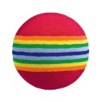



**3**

**2**

**1**







**0/7 Estimate and check by counting**

**I estimate there are 6 apples here.**

** Check by counting!**

**0/8 More and fewer**

**1 2 3 4 5 6**

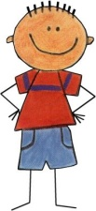****

**1 2 3**

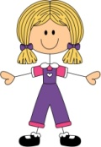****

Fewer girls

More boys

**0/9 Total number in two groups**

**http://www.mathsisfun.com/activity/images/dice3.gif**

Dice 1 Dice 2 altogether

**Put bigger number first**

**0/10 & 11 One more and one less**

|  |  |  |
| --- | --- | --- |
| **4** | **5** | **6** |
| **http://upload.wikimedia.org/wikipedia/commons/f/fd/Light_Green_Lego_Brick.jpghttp://upload.wikimedia.org/wikipedia/commons/f/fd/Light_Green_Lego_Brick.jpghttp://upload.wikimedia.org/wikipedia/commons/f/fd/Light_Green_Lego_Brick.jpghttp://upload.wikimedia.org/wikipedia/commons/f/fd/Light_Green_Lego_Brick.jpg** | http://upload.wikimedia.org/wikipedia/commons/f/fd/Light_Green_Lego_Brick.jpg**http://upload.wikimedia.org/wikipedia/commons/f/fd/Light_Green_Lego_Brick.jpghttp://upload.wikimedia.org/wikipedia/commons/f/fd/Light_Green_Lego_Brick.jpghttp://upload.wikimedia.org/wikipedia/commons/f/fd/Light_Green_Lego_Brick.jpghttp://upload.wikimedia.org/wikipedia/commons/f/fd/Light_Green_Lego_Brick.jpg** | **http://upload.wikimedia.org/wikipedia/commons/f/fd/Light_Green_Lego_Brick.jpghttp://upload.wikimedia.org/wikipedia/commons/f/fd/Light_Green_Lego_Brick.jpghttp://upload.wikimedia.org/wikipedia/commons/f/fd/Light_Green_Lego_Brick.jpghttp://upload.wikimedia.org/wikipedia/commons/f/fd/Light_Green_Lego_Brick.jpghttp://upload.wikimedia.org/wikipedia/commons/f/fd/Light_Green_Lego_Brick.jpghttp://upload.wikimedia.org/wikipedia/commons/f/fd/Light_Green_Lego_Brick.jpg** |

**5**

**7**

**6**

**4**

6 is 1 more than 5

**5**

4 is 1 less than 5

**0/12 Positional language**

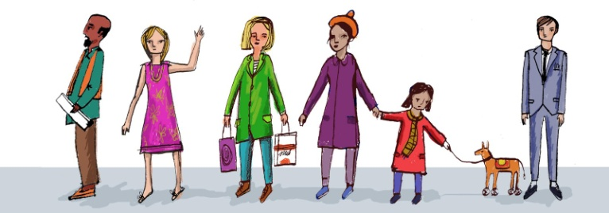

**1 2 3 4 5 6 7**

first

second

third

**0/13 Shapes of everyday objects**

* 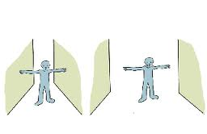Tall and short / narrow and wide

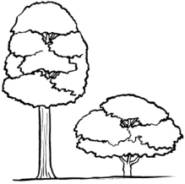

* 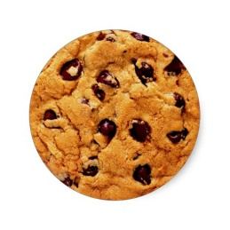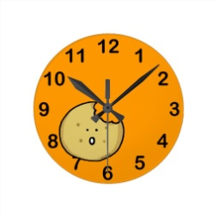Round shapes

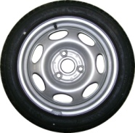

* Triangle shapes



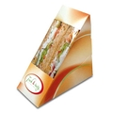

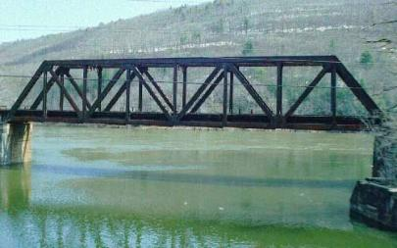

**0/14 Names of 2D shapes (flat shapes)**

|  |  |
| --- | --- |
| **Name of shape** | **Example in everyday life** |
| Triangle | http://www.roadcover.co.za/wp-content/uploads/2011/10/children-crossing-triangle-sign.jpg |
| Circle | http://www.rivercitypizza.com/PepperoniPizza-full.jpg |
| Square | http://thumbs.dreamstime.com/x/single-cream-cracker-biscuit-white-background-15516653.jpg |
| Rectangle | http://www.munsterjoinery.co.uk/files/p_20100809040126heritage_single_door.jpg |

**0/14 Names of 3D shapes (solid shapes)**

|  |  |
| --- | --- |
| **Name of shape** | **Example in everyday life** |
| Cone | http://t0.gstatic.com/images?q=tbn:ANd9GcSu3bJC6cdujtqAzGnEm4yL-qBMphmupLcBBp80wJixQ3ZEASwN |
| Cube | http://www.clker.com/cliparts/6/4/1/6/12456404511653839274badaman_dice.svg.hi.png |
| Cuboid | http://moneysavingmom.com/images/2008-small/08/19/300pxwiki_cheerios.jpg |
| Sphere | https://encrypted-tbn3.gstatic.com/images?q=tbn:ANd9GcQRjxntSqLEuJp2_FOLw4_F5wv7p7qS_5hoytnN4OPxdnYdHKj5 |
| Cylinder | http://www.hitched.co.uk/chat/cfs-file.ashx/__key/CommunityServer.Components.PostAttachments/00.00.90.35.51/Tin-of-beans-on-white.jpg |
| Pyramid  https://encrypted-tbn3.gstatic.com/images?q=tbn:ANd9GcQQQITtt-Pl_y17Ecz65OO_nD75LXBcFVXX8ztWPlOGZTZIK4aZAQ | http://www.fi.edu/learn/tut/images/tut_pyramid.jpg |

**0/15 Relative position**

|  |  |  |
| --- | --- | --- |
| http://bestclipartblog.com/clipart-pics/cat-clipart-6.gif | http://imagesci.com/img/2013/10/rabbit-drawing-23987-hd-wallpapers.jpg | https://encrypted-tbn2.gstatic.com/images?q=tbn:ANd9GcRbkUKjkfehXogLzeMgCmgI8eACzlfklfDGA-zmNyNoYT8_DTHQ |
| http://www.art-made-easy.com/images/horse-drawing5.jpg | http://petsbunch.com/wp-content/uploads/2013/12/buying-guinea-pigs-342.jpg | http://www.easy-drawings-and-sketches.com/images/how-to-draw-a-fish04.jpg |

The rabbit is between the cat and dog.

The horse is left of the guinea pig.

The fish is below the dog.

The cat is above the horse.

The rabbit is to the right of the cat.

**0/16 Order length**

* Find the shortest – put it at the beginning
* Find the longest – put it at the end

Shortest

Longest

**0/17 Order weight**

* Find the lightest – put it at the beginning
* Find the heaviest – put it at the end

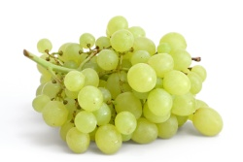

Lightest

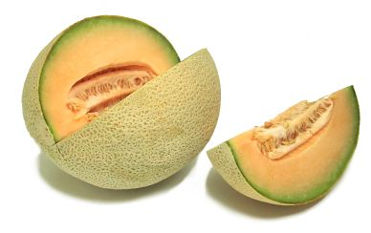

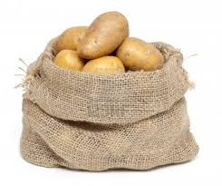

Heaviest

**0/17 Order capacity (continued)**

* Find the smallest capacity – put it at the beginning
* Find the largest capacity – put it at the end

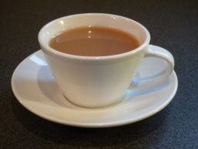

Smallest capacity

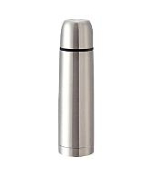

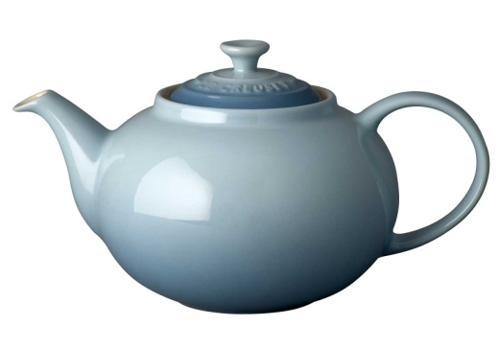

Largest capacity

**0/18 Everyday language related to time**

* The months and seasons

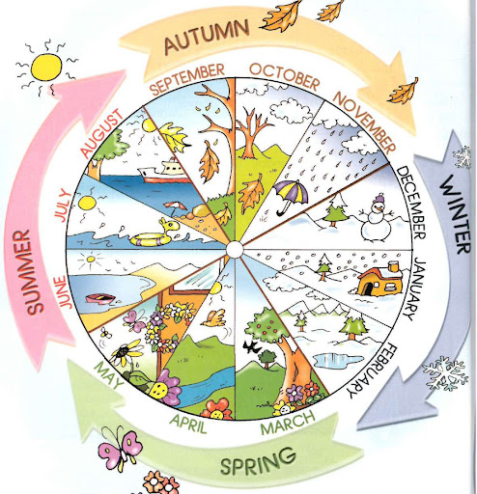

* The days of the week

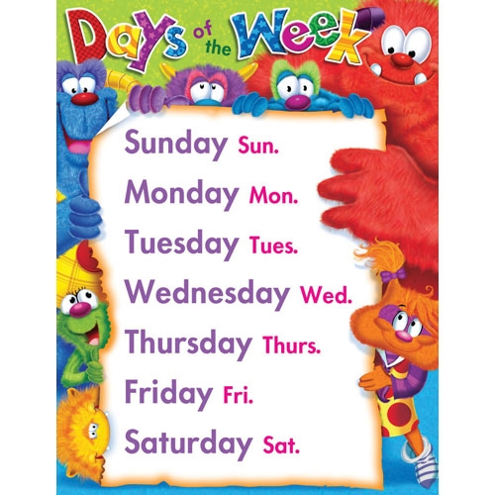

* Parts of a day

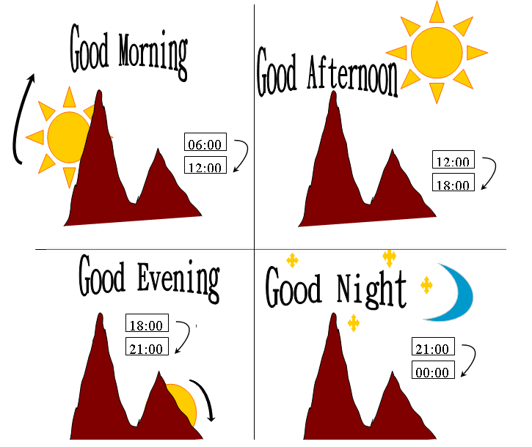

**0/19 Everday language related to money**

Our coins

1p 2p 5p 10p

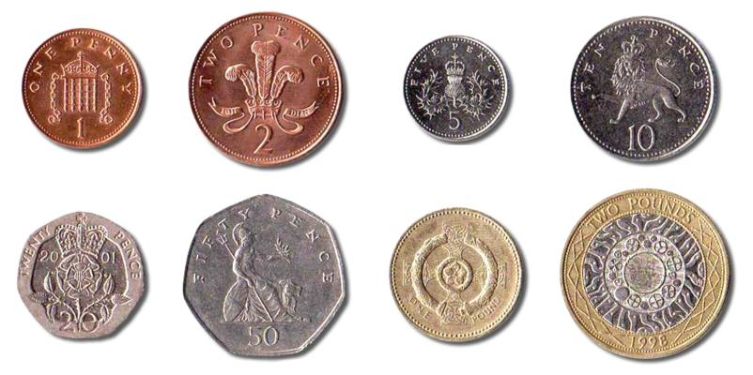

20p 50p £1 £2

Discuss shape and colour of the coins

**0/20 Sequence familiar events**

**A B**

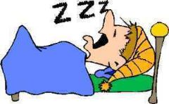****

**C D**

A – Get out of bed

C – Clean teeth

D – Go to school

B – Go to bed