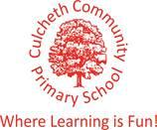

Our Sporting Diary 2022 - 2023

September

School Games Mark
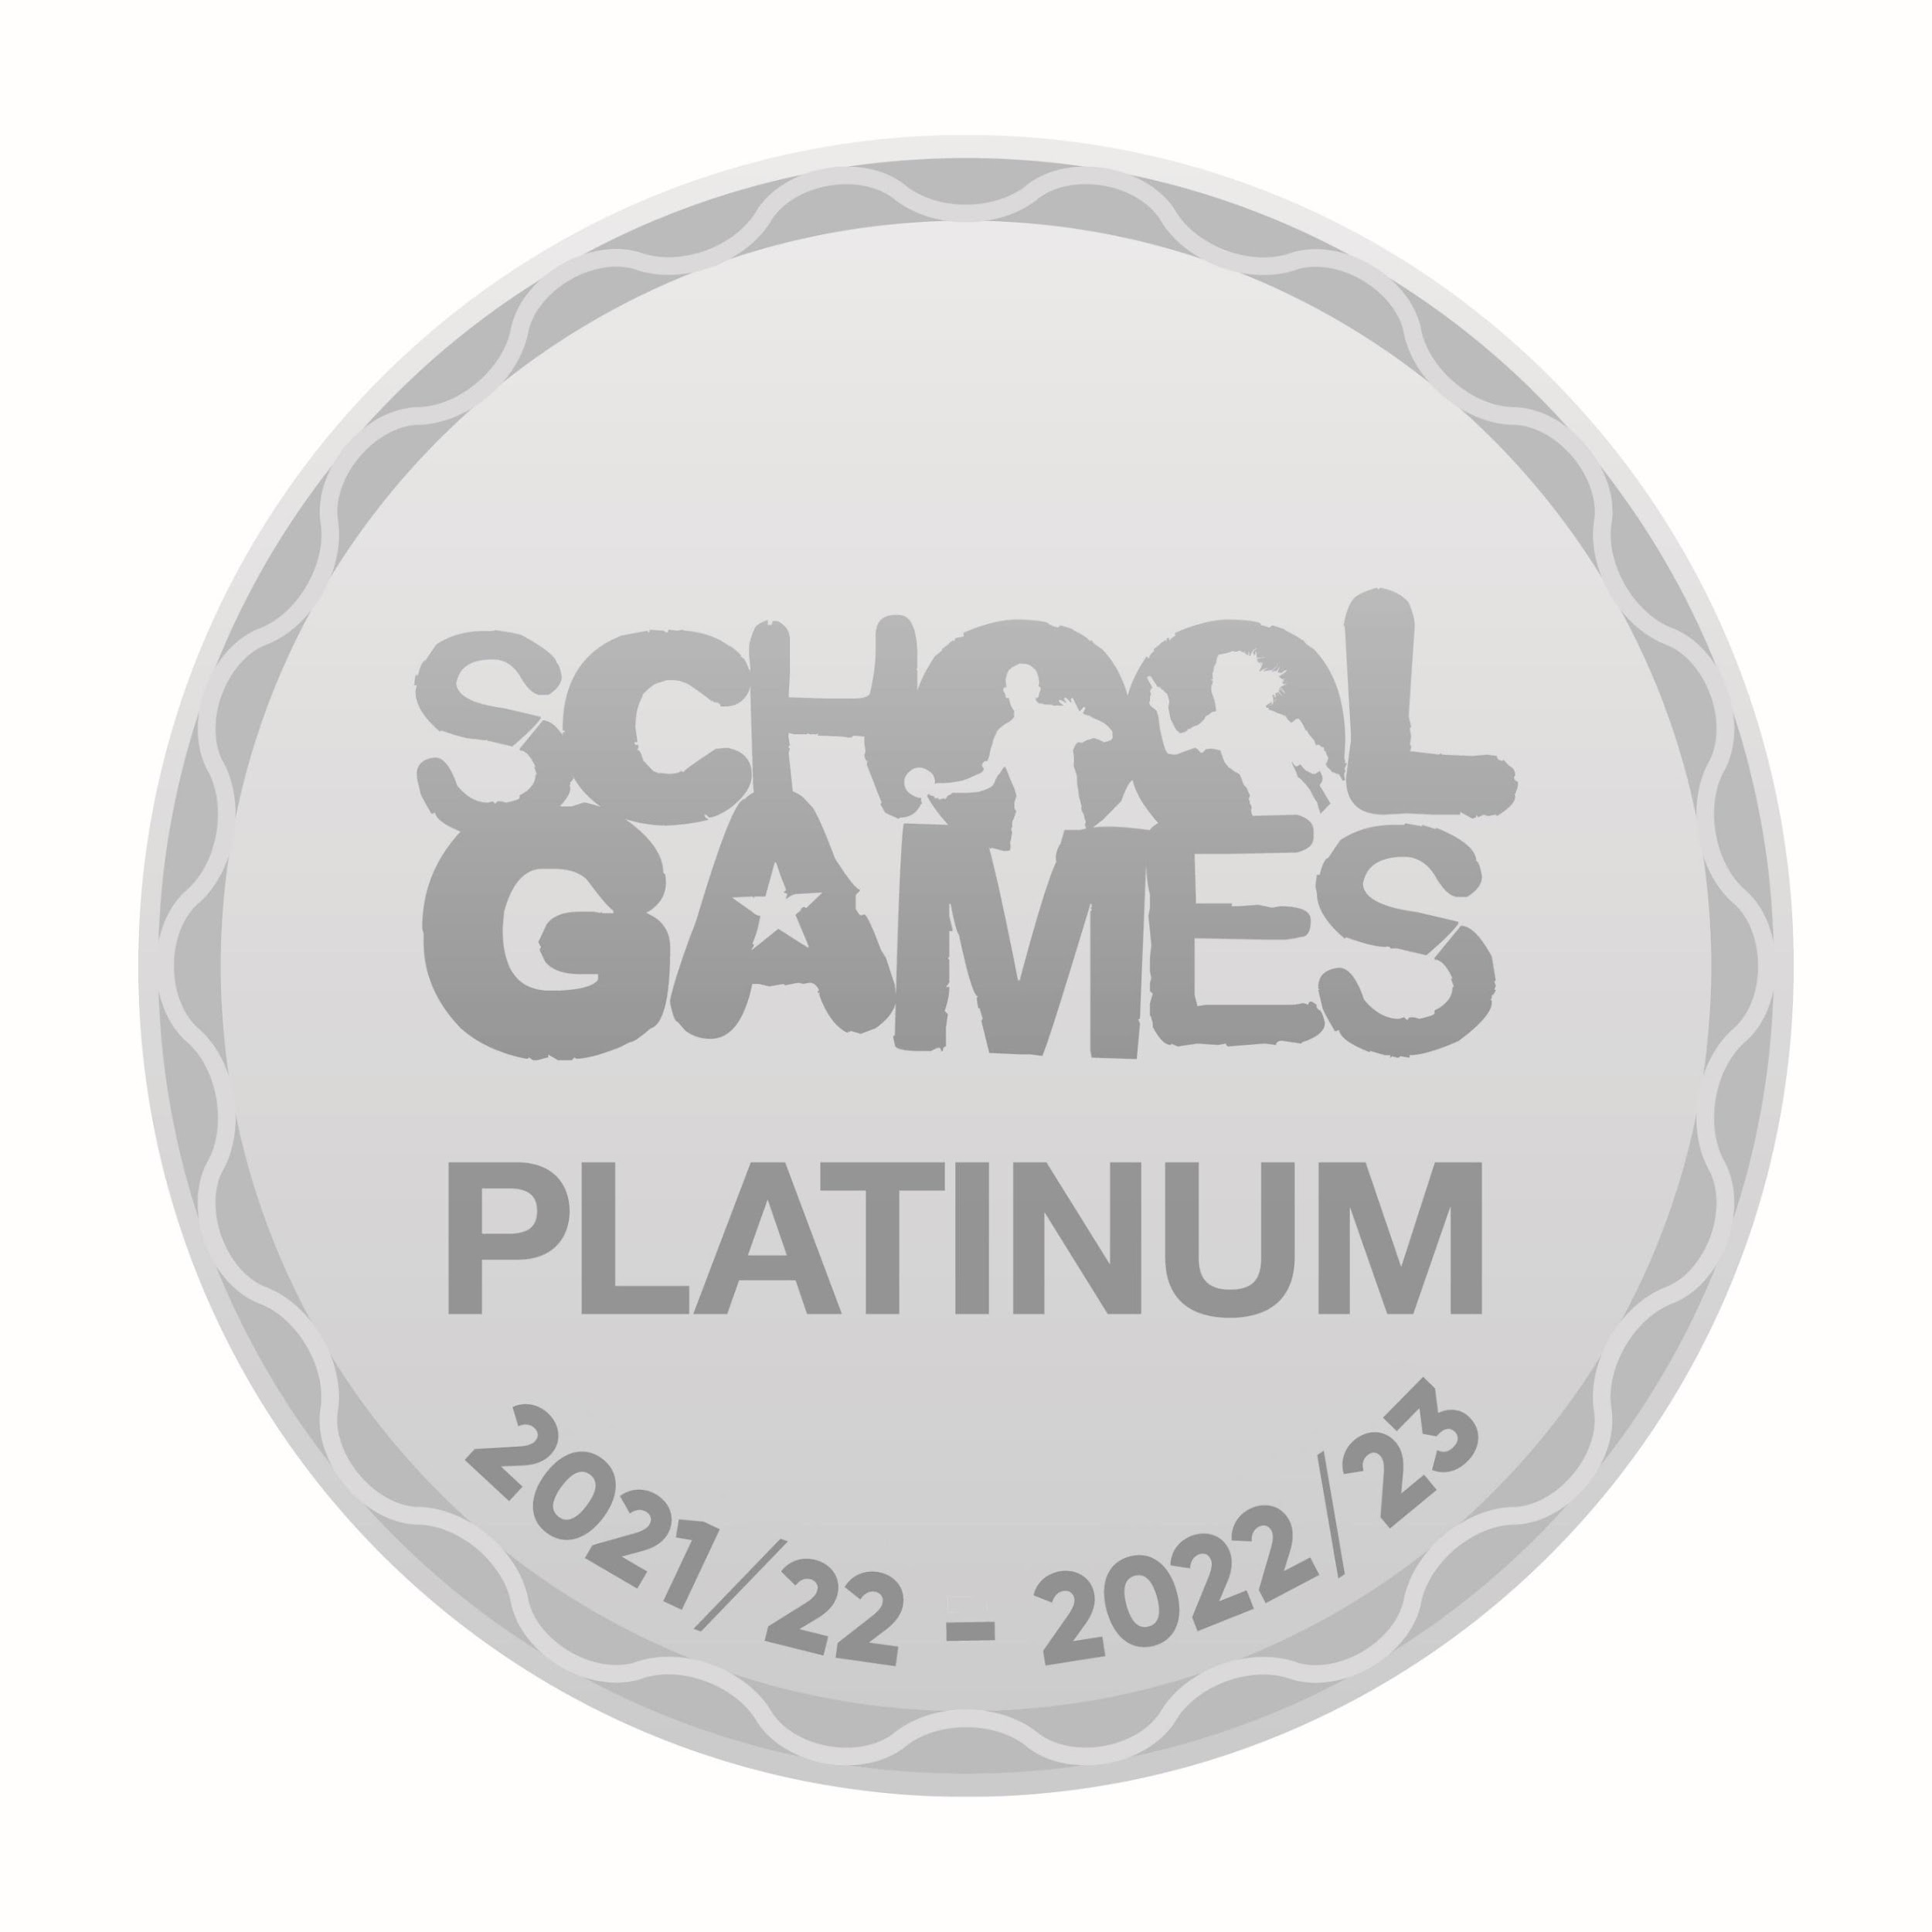
We finally reached PLATINUM! So why did we receive PLATINUM? As part of our application, we were asked to fulfil criteria in the areas linked to the five School Games outcomes which were: Maintaining and growing our school’s engagement in the School Games and their delivery of 60 active minutes for every child; Creating positive experiences of our young people; A clear focus on transition points; Creating positive experiences that support to the lives of children and young people. We are pleased that the hard work of everyone at our school has been rewarded this year.

Sports Assemblies
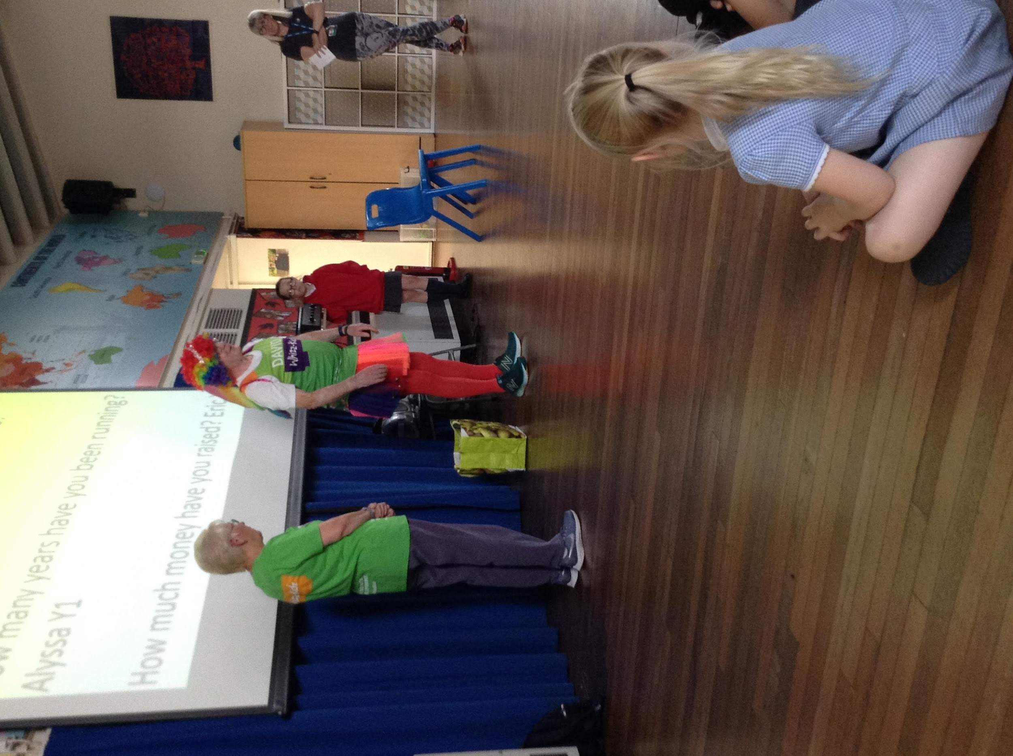
Our sports assemblies are continuing every Tuesday afternoon from 2.50pm. We celebrate children’s sporting achievements outside of school as well as school-based competitions. The children have the opportunity to bring in certificates and trophies and explain why they have achieved this and what it is for. We also look at different sports people each week, sharing their sporting experiences and achievements with the school. The children love celebrating in their sporting achievements. We look forward to hearing all about your sporting achievements both in and outside of school this year!

Daily Mile
The Daily Mile is 15 minutes when our children jog or run, at their own pace, during the school day at a time of the teacher's choosing.
New PE kits!
We have amazing new PE tops for every child in school.

After School Clubs
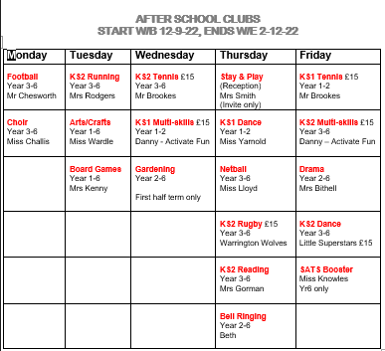
We have an array of sporting after school activities at Culcheth. This helps to promote physical activity to all children. At Culcheth Community Primary School, we provide opportunities for children to become physically confident as well as compete in sport and other activities to build character and help to embed values such as fairness and respect.

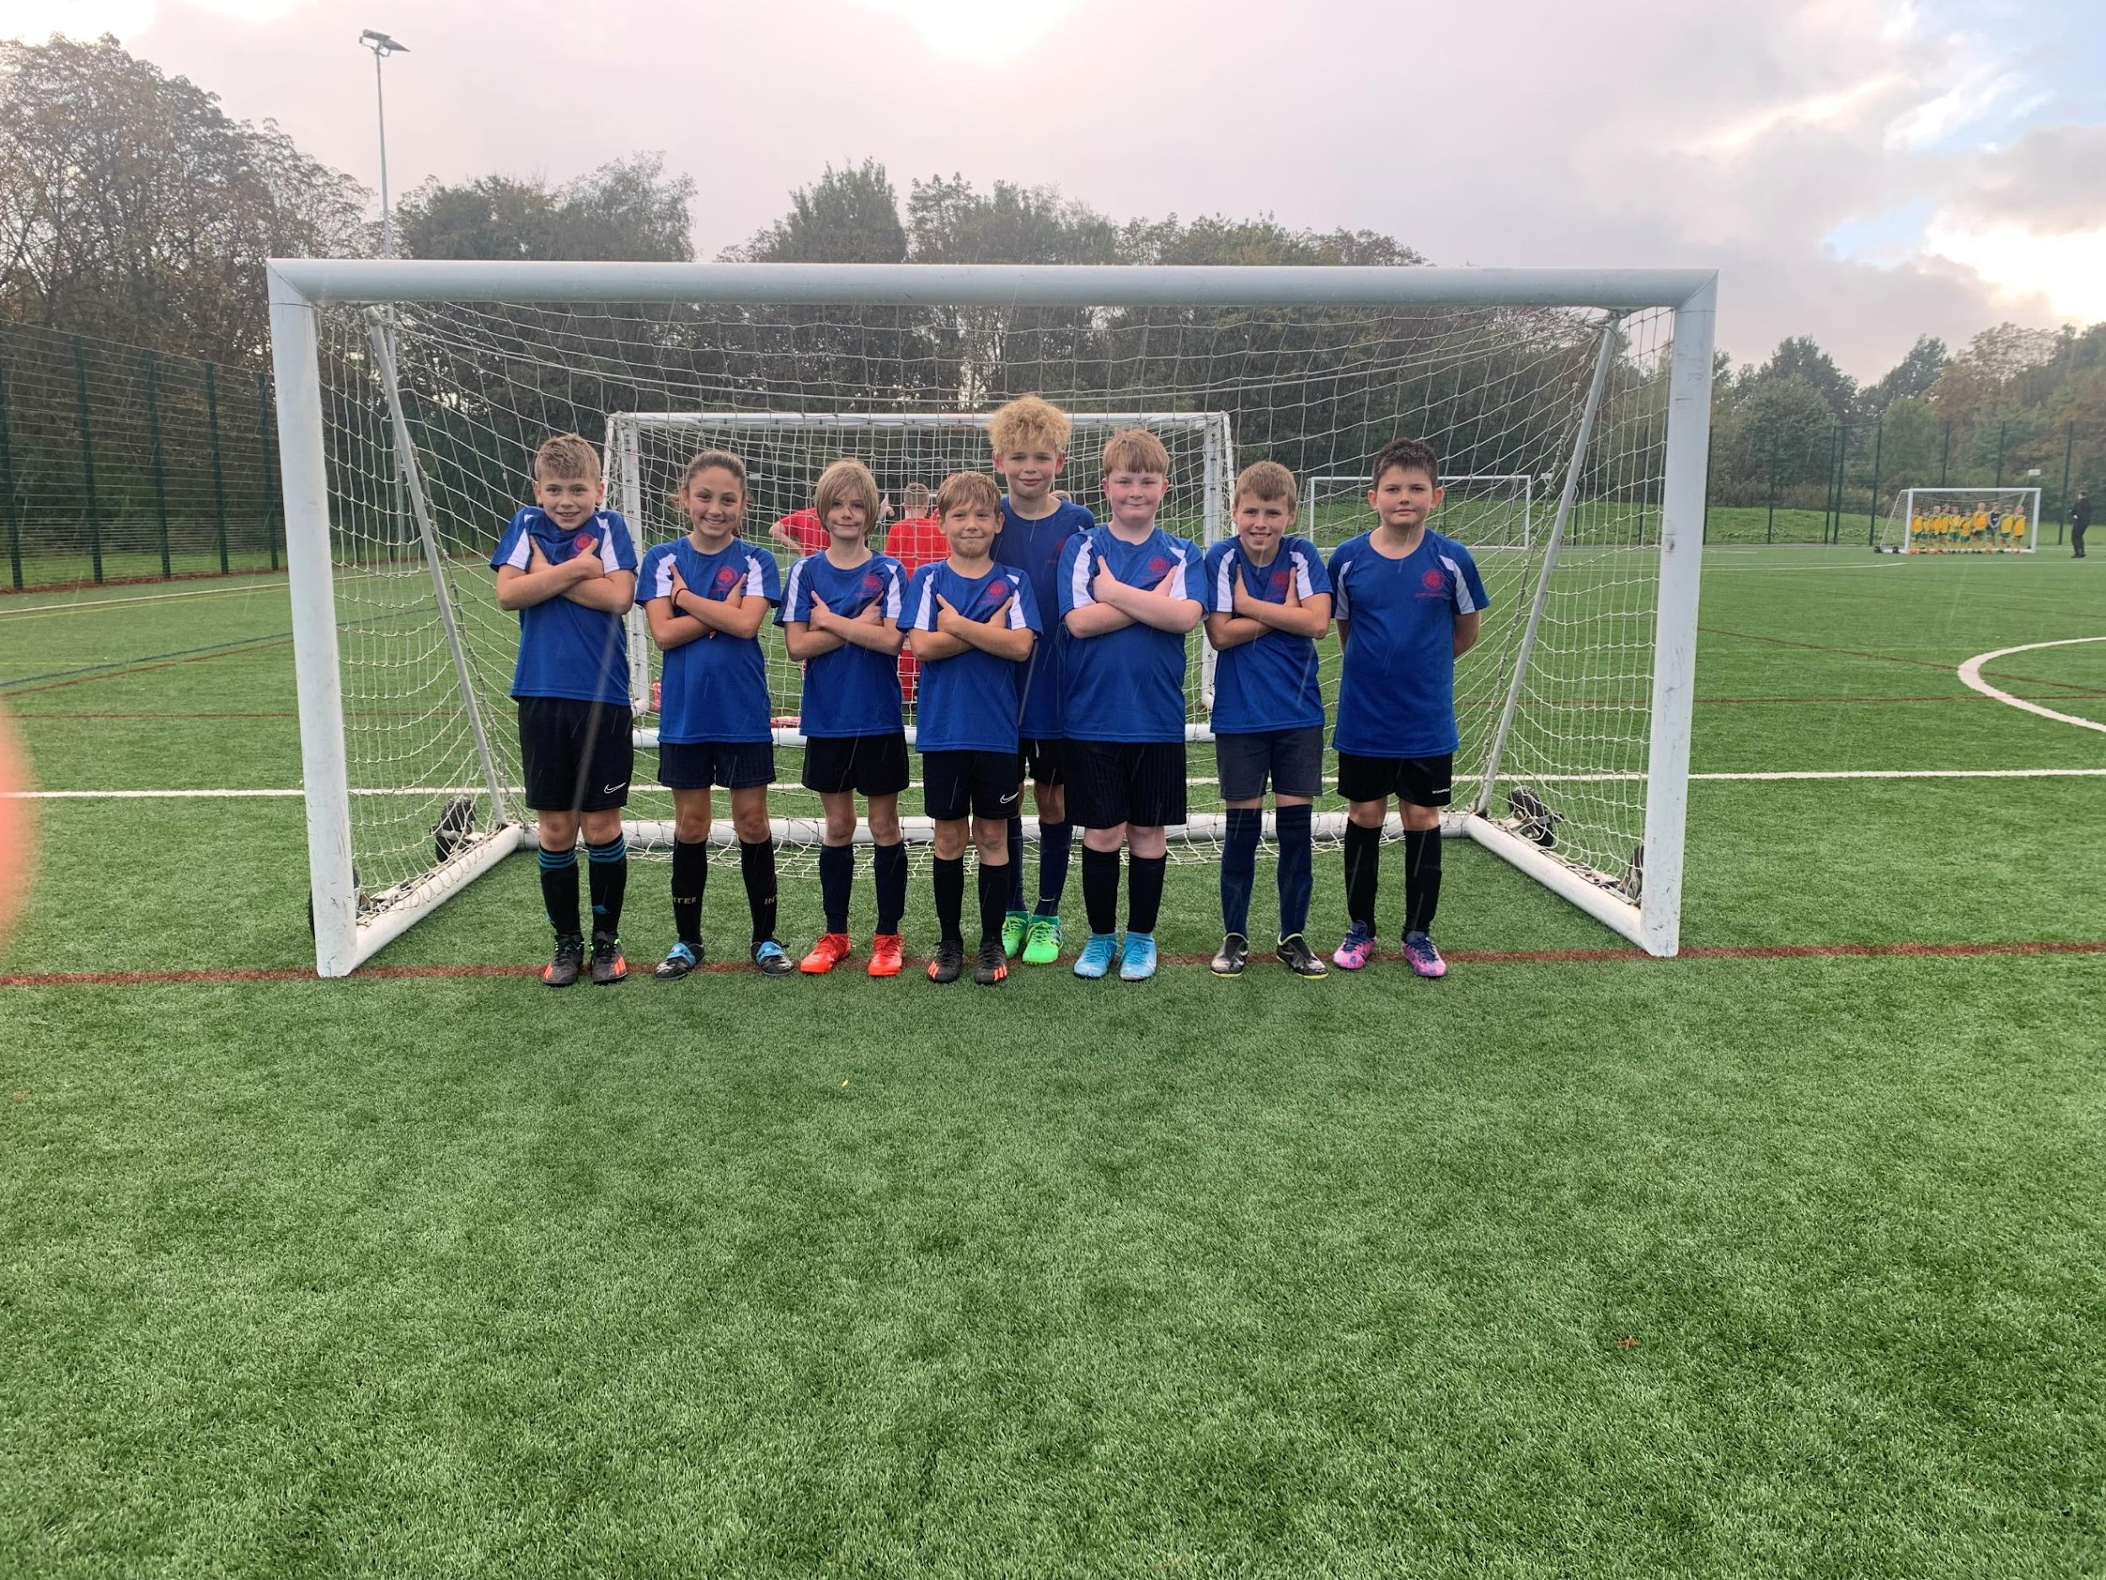
Year 5 and Year 6 Football Tournament
Our Year 5 & 6 football team took part in a tournament at Birchwood High School yesterday. The team played with 3 wins, 2 defeats and 4 draws. Some great goals but a special mention to Fin for the goal of the tournament! Well done Team Culcheth!

October

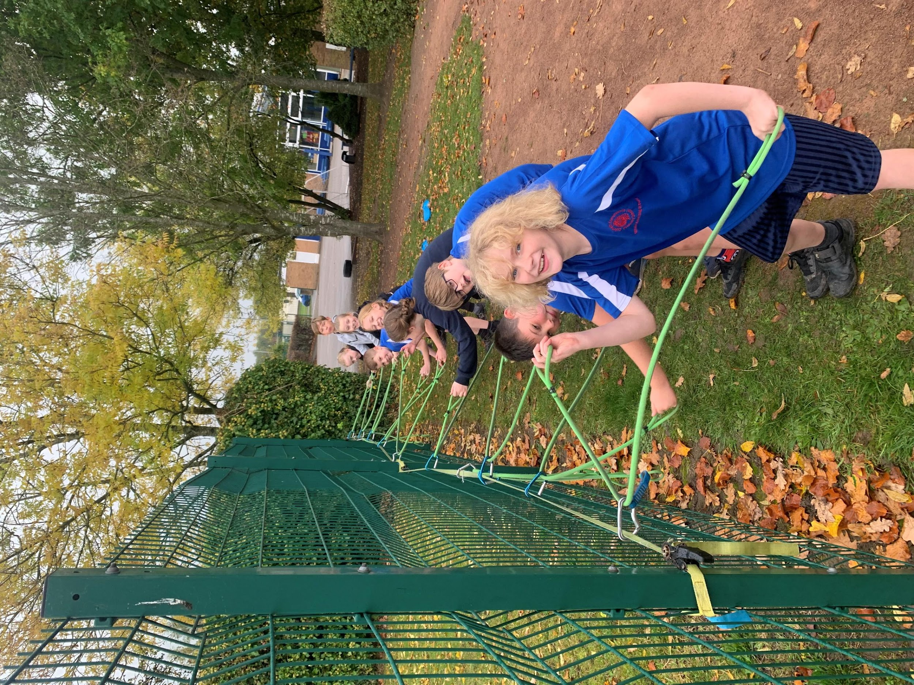
TriKidz
TriKidz- our children had the amazing opportunity to try to develop their Triathlon skills in school - they were awesome! TriKidz Charity Project came into school to work with Years 1 to 6. The Trikidz aim is to deliver triathlon coaching in primary schools throughout the North West to encourage children to be active and enjoy multisport. We all had great fun and the children loved it! We did however end up a little muddy!!!!
Walton Gardens Race
A great result last Saturday for Culcheth at the Walton Gardens Cross Country Tournament. The girls are currently in 3rd place out of 27 schools and the boys are 5th/6th overall. The next race is on Saturday 19th November and we can't wait. We train for this every Tuesday at running Club hosted by Mrs Rodgers!! Well done Culcheth Runners!!
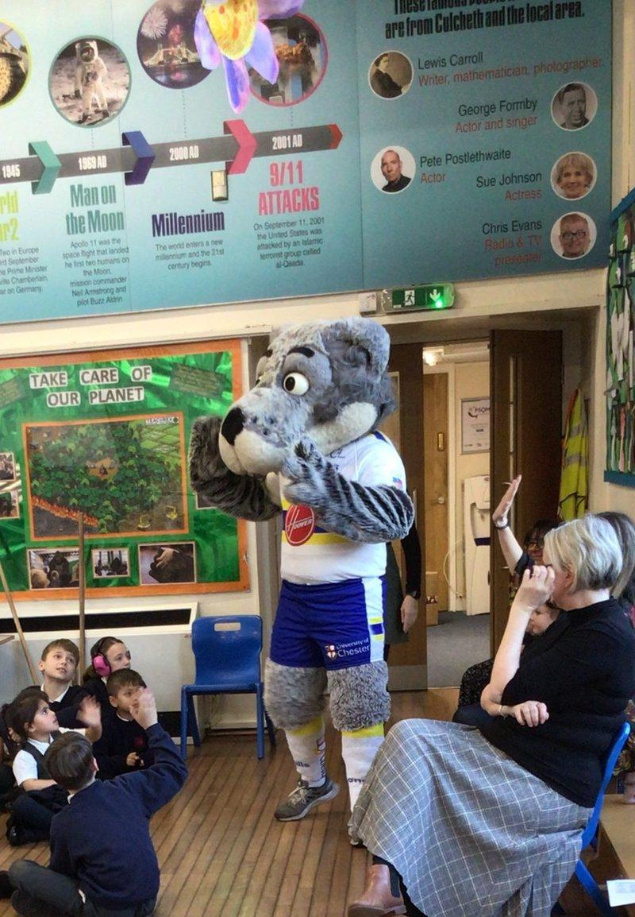
November

Anti-bullying week- Wolfie Visit
During anti-bullying week, we had a very special visit from the Warrington Wolves mascot WOLFIE! He came to talk to us about Anti-bullying week and provided the children with lots of information. Luckily, it was also our sports assembly and he helped Mrs Rodgers hand out certificates!

Y5&6 Netball
Congratulations to all the children who took part in the Y5/6 netball tournament on Thursday and WON!!! The winners automatically progress through to the Warrington Town Finals. Go Team Culcheth, you are amazing!!!

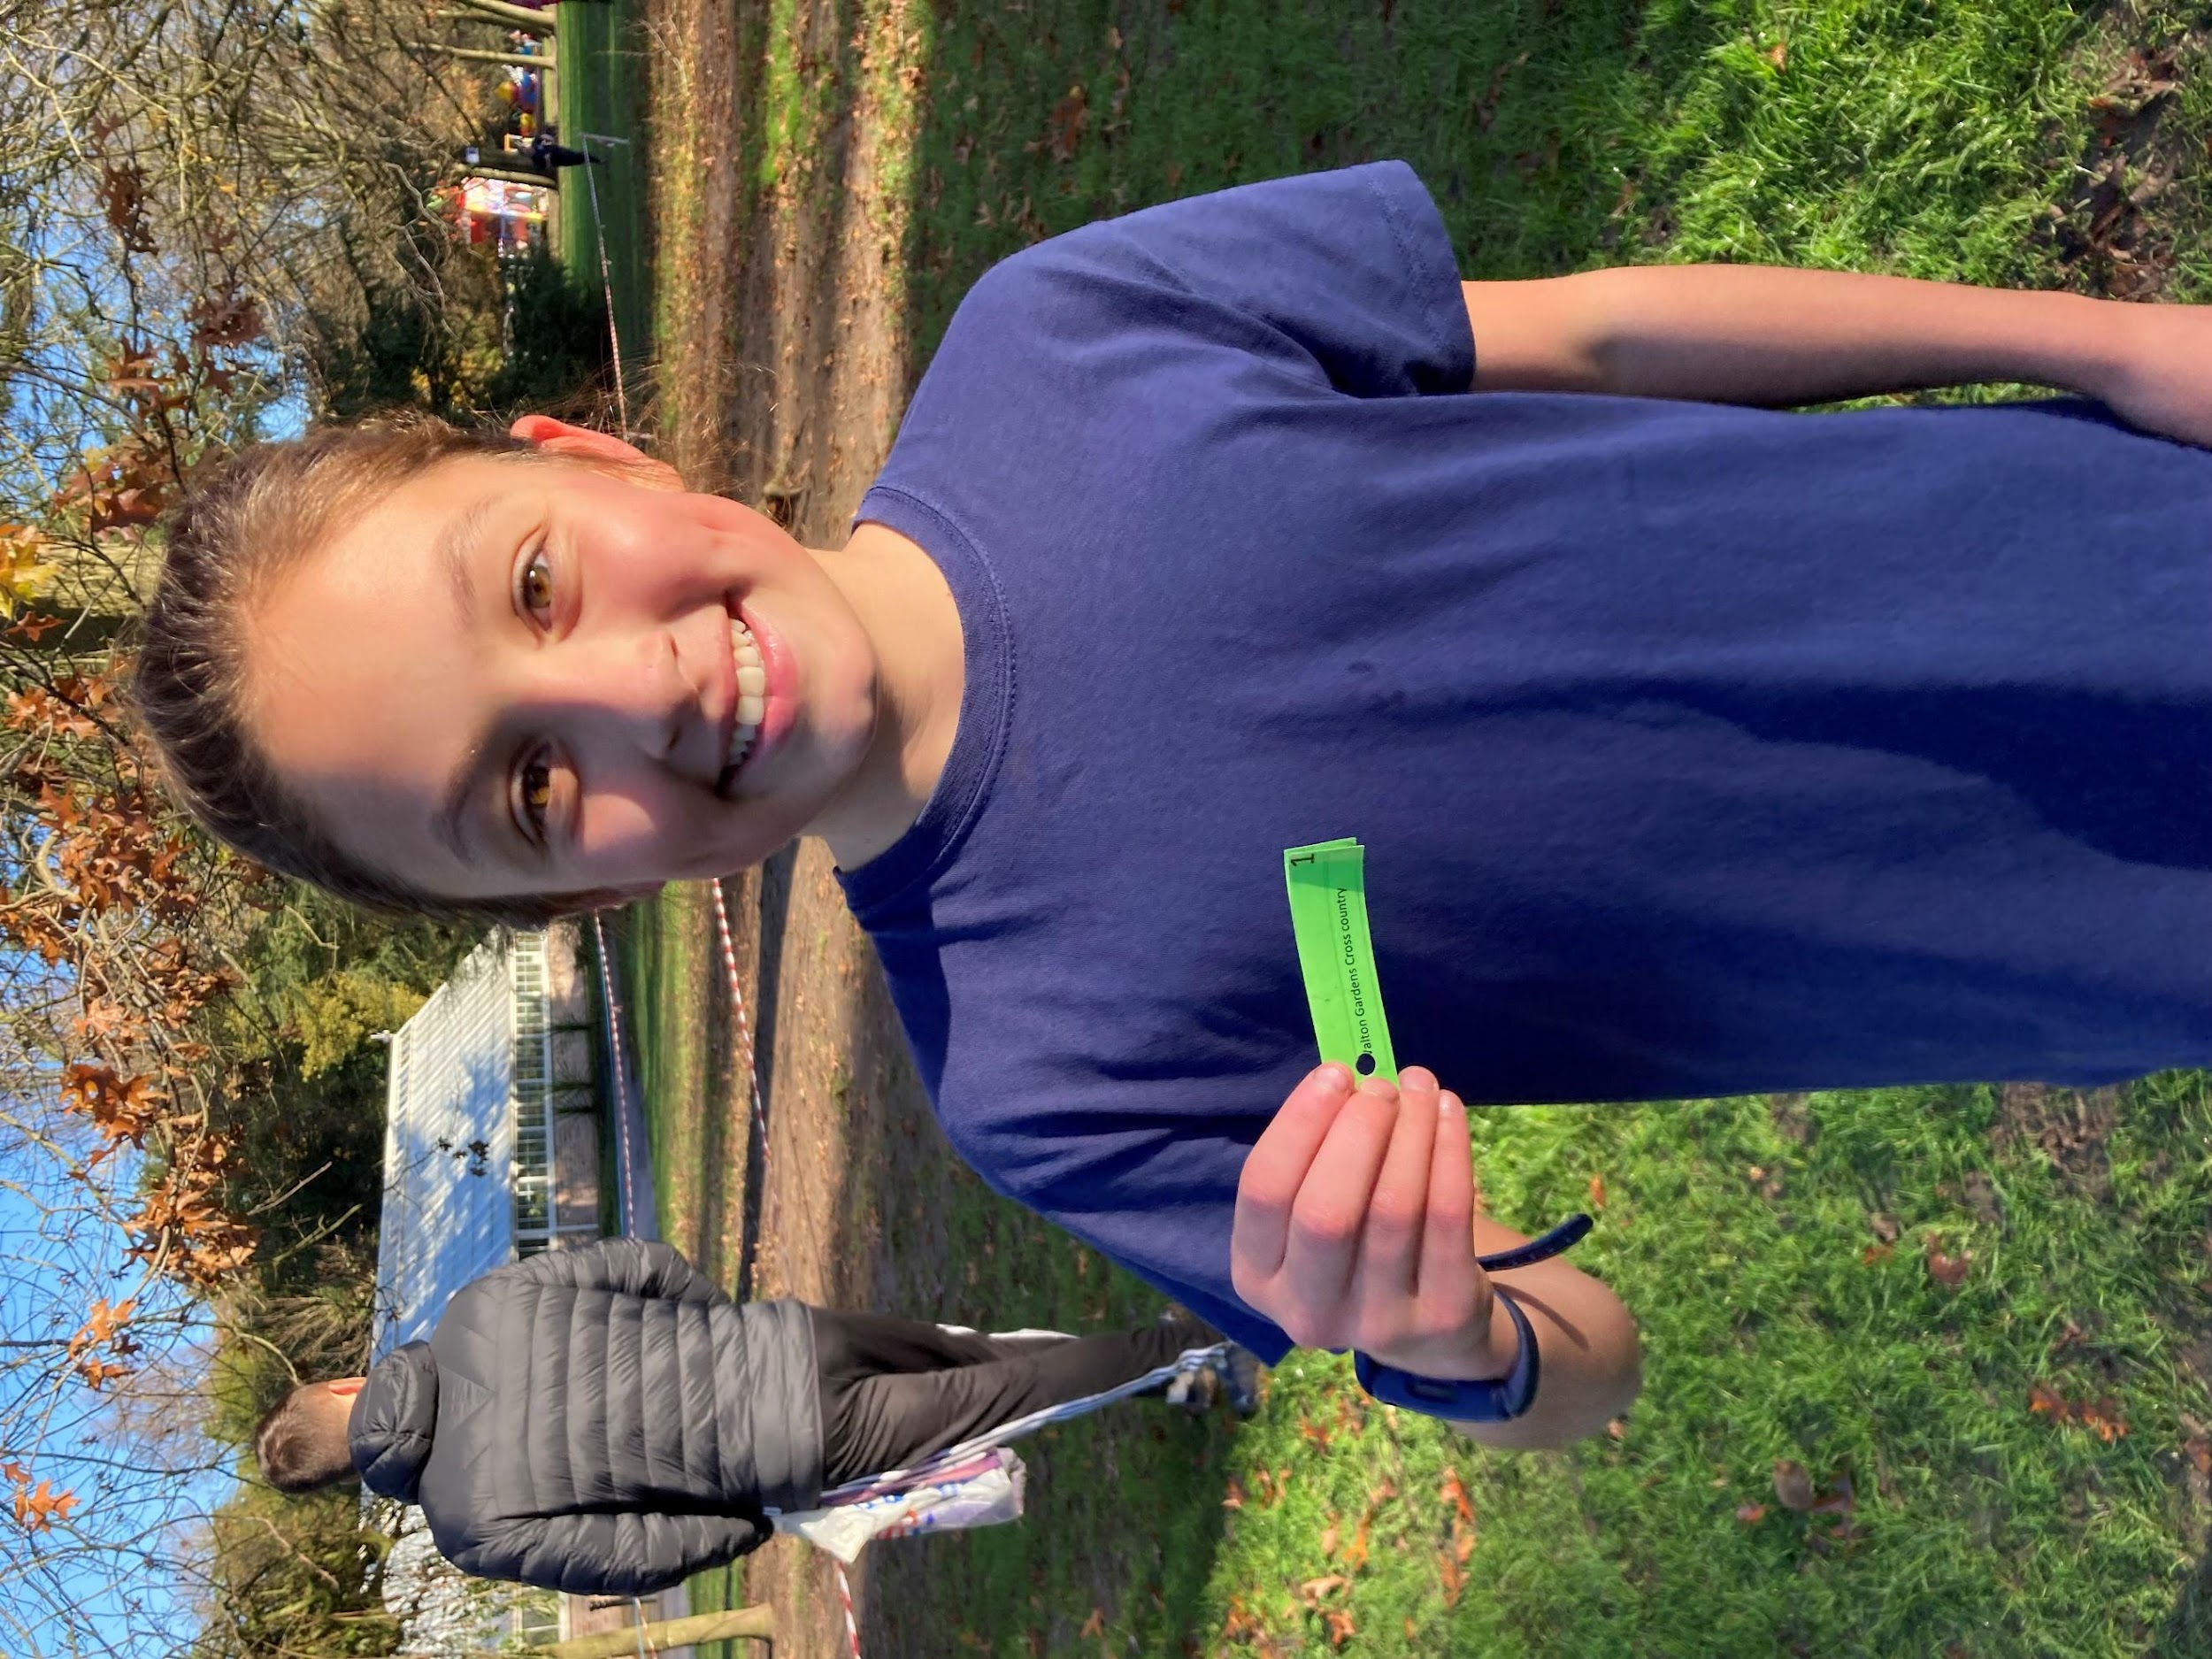
Walton Gardens Race
A great result last Saturday for Culcheth at the Walton Gardens Cross Country Tournament. Well done to Pip for coming first twice in a row. Overall results still to continue. Next race will be 10th December. Good Luck Team Culcheth!!

December

Y3 & 4 Football Tournament
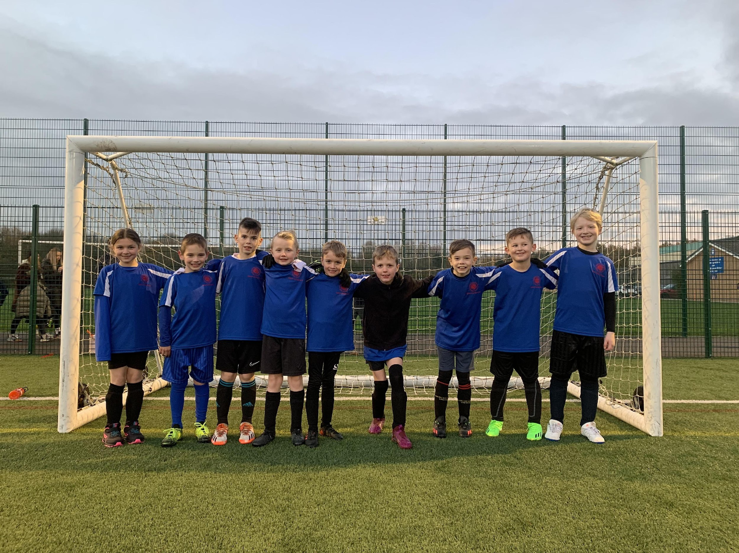
Well done to our Year 3 & 4 football team who played in a competition yesterday at Birchwood. They won 1, drew 3 and lost 1. A big shout out to Alby's last-minute super save!!! Well done to everyone, Miss Lloyd is very proud of you.

Sports Crew Meeting
On Wednesday 7th December we held our first Sports Crew meeting of the year. The Sports Crew is made up of lower and upper Ks2 children. The agenda for this meeting was based on teamwork. The children discussed how they would like to have monitors at breaktime that will promote exercise and games. The next meeting will be held on Wednesday 25th January.

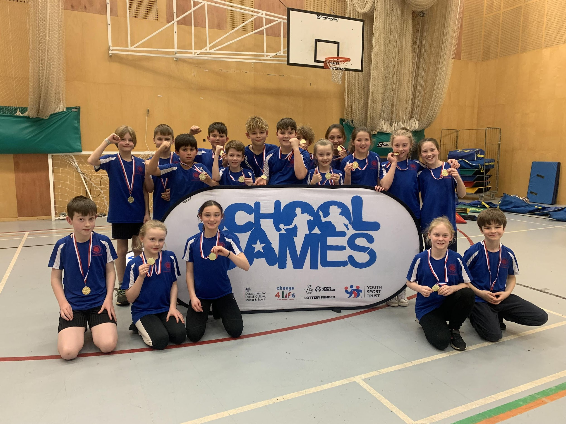
January
Y5&6 Athletics Qualifier
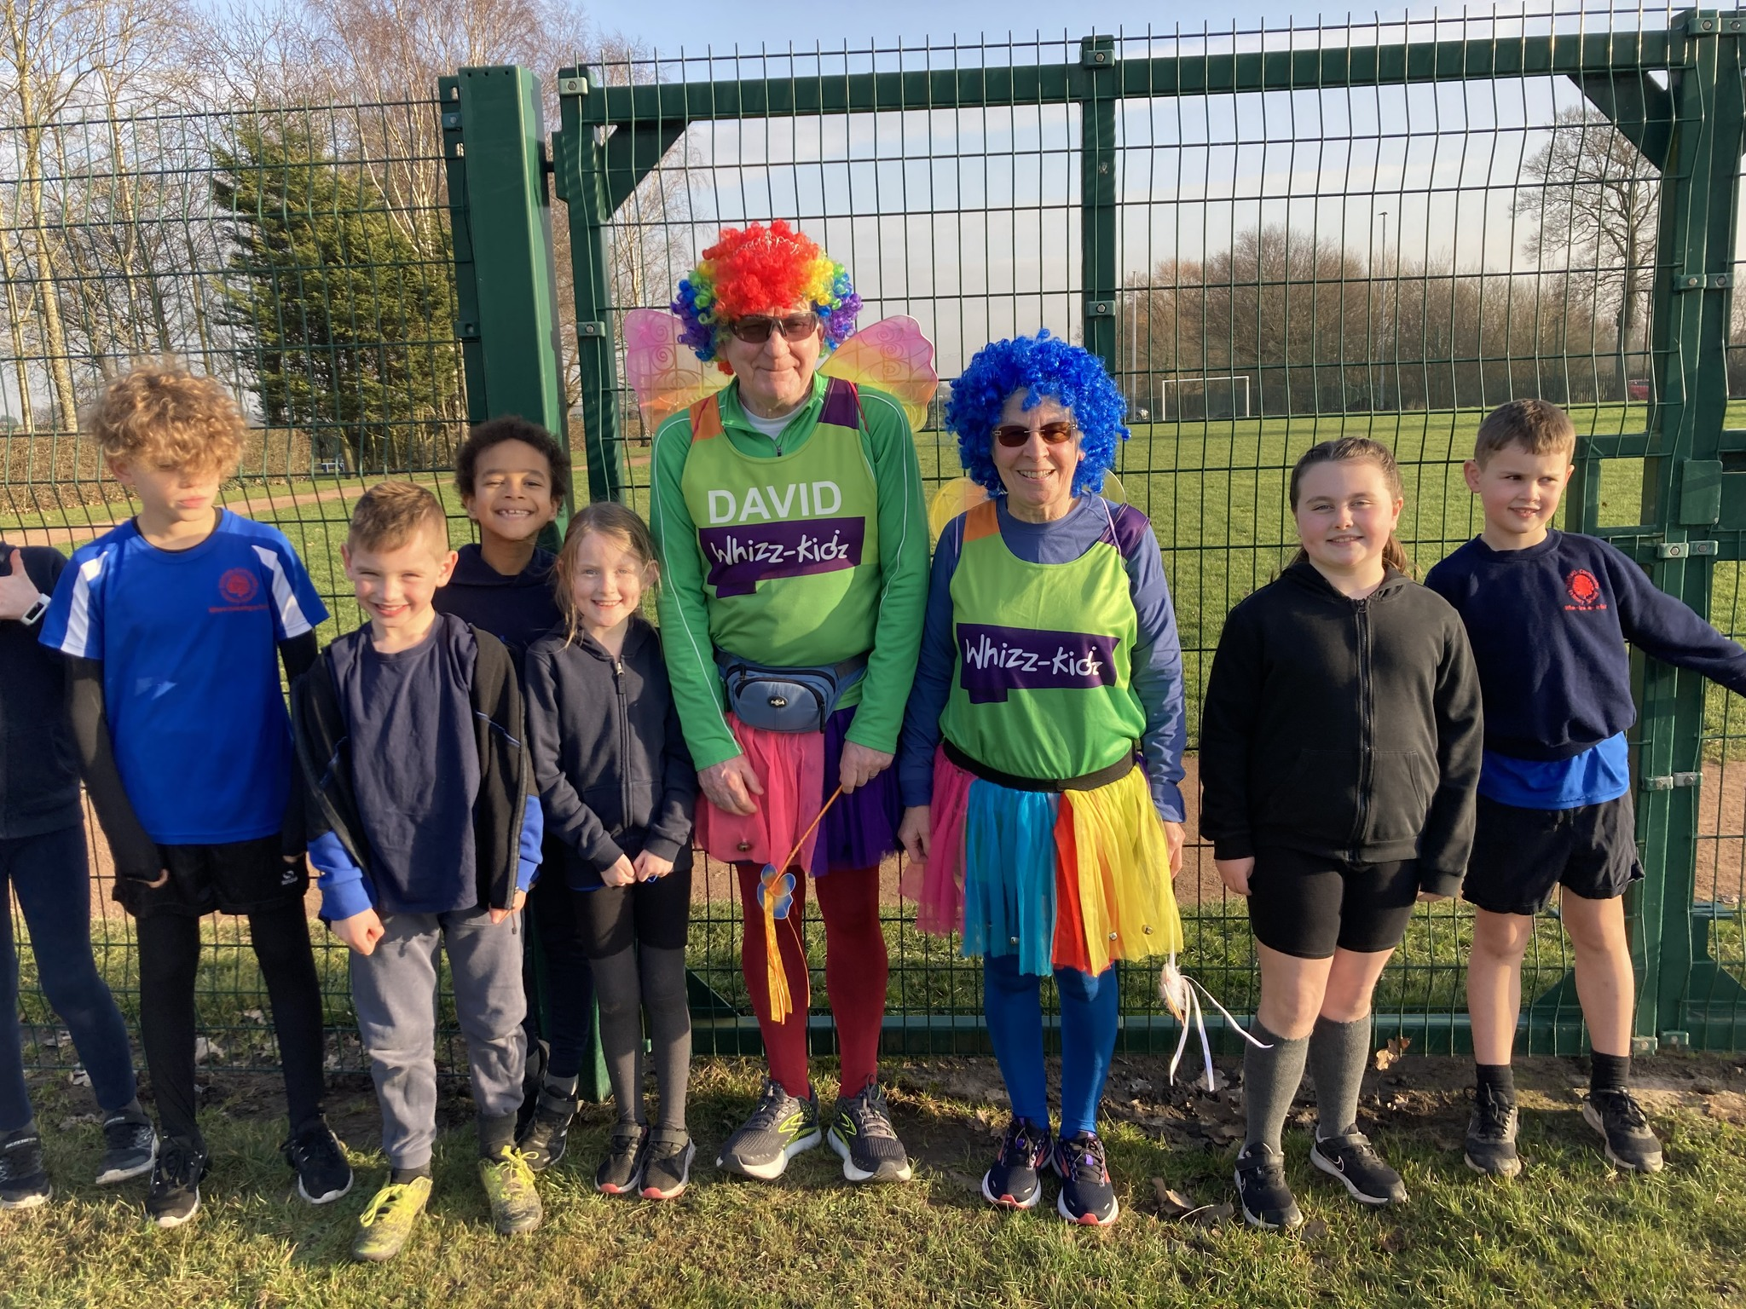
Congratulations to Y5&6 for qualifying for the Warrington Finals at Birchwood High School on the morning of Tuesday 7th February 23! Me and Mrs Rodgers are extremely proud to announce that we have qualified in 1st place out of 5 schools to be able to attend the Warrington Town Finals in February! All children, who took part, performed excellently and represented Culcheth Primary School very well. Go team CULCHETH!
February

The Culcheth fairy is training for the London marathon and Culcheth Primary are going to help! David will be attending our weekly running club to get him marathon ready!

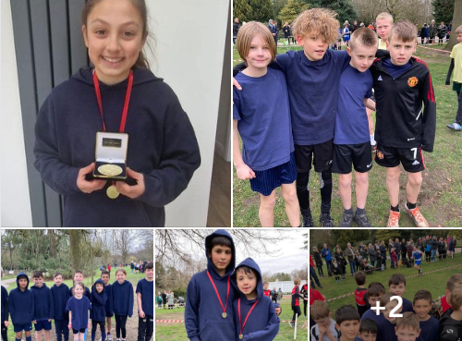
March

Massive well done to Culcheth Running Team today at the Walton Gardens Cross Country final. We are thrilled to announce that Pip came first over all. The Year 6 boys team came 2nd. Special mention to our youngest runners: Annabelle, William, Diesel and Teddy. Well done to all the running team, Mrs Rodgers is very proud of you all.
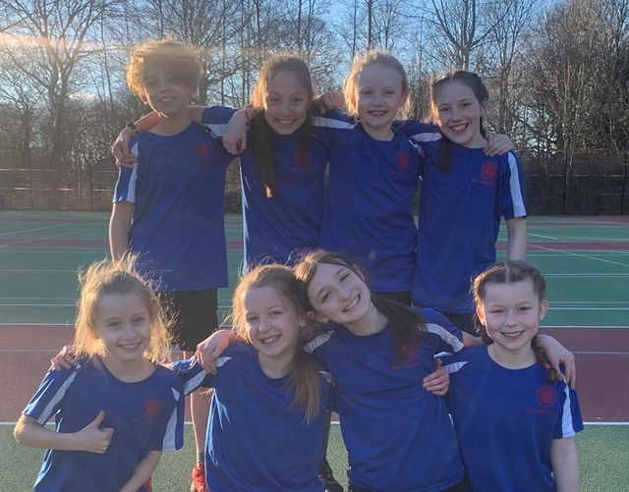

We are very proud of our Netball team who competed in a Netball tournament this week. Out of 38 schools, they made it to the final 10 and played their hearts out. Mrs Rodgers and Miss Lloyd are very proud of their effort and determination. Well done Team Culcheth

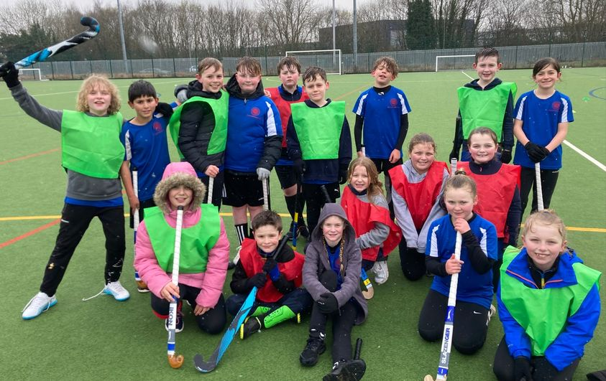

A great effort by our Hockey Team yesterday, Mrs Rodgers is very proud!

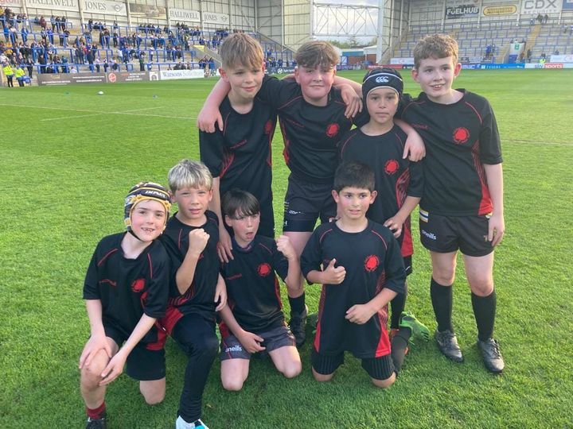

May
Absolutely thrilled with our Rugby boys! We WON all our games and never conceded any tries! The lads were truly awesome, roll on the final!

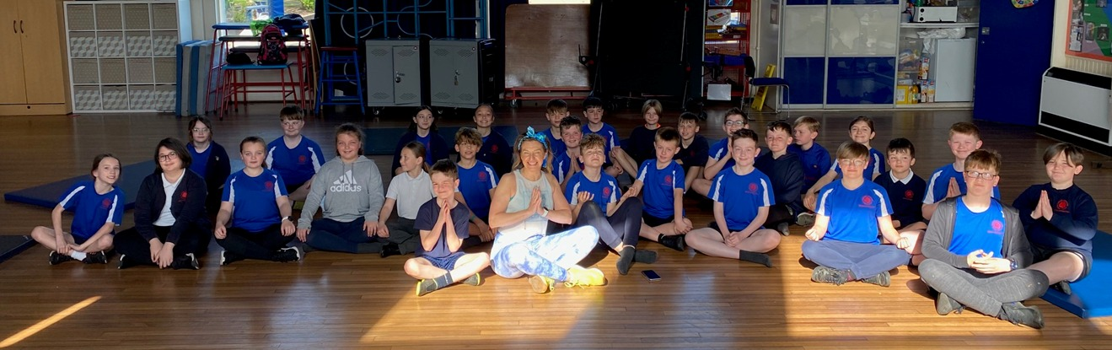
Year 6 have had a great time working with Nicola from Great New Beginnings over the past few weeks. They have learnt all kinds of Yoga, relaxation and breathing techniques in preparation for SATS next week. Nicola will now be doing some work with Year 5.

June
July

