**Culcheth Primary Sports Diary 2024-2025**

**September**

**Weekly Sports Assembly**

**Y4 Football Tournament- Everton Youth Academy**



**Walton Gardens Cross Country**

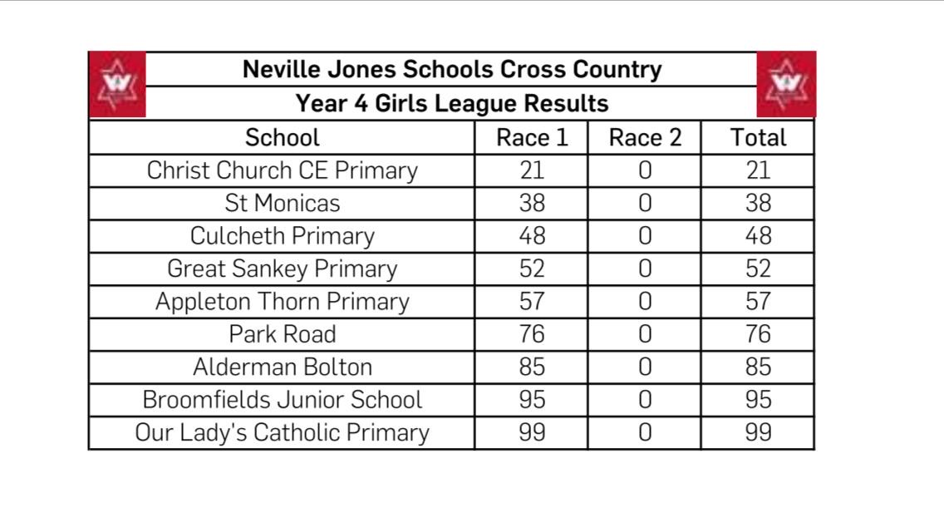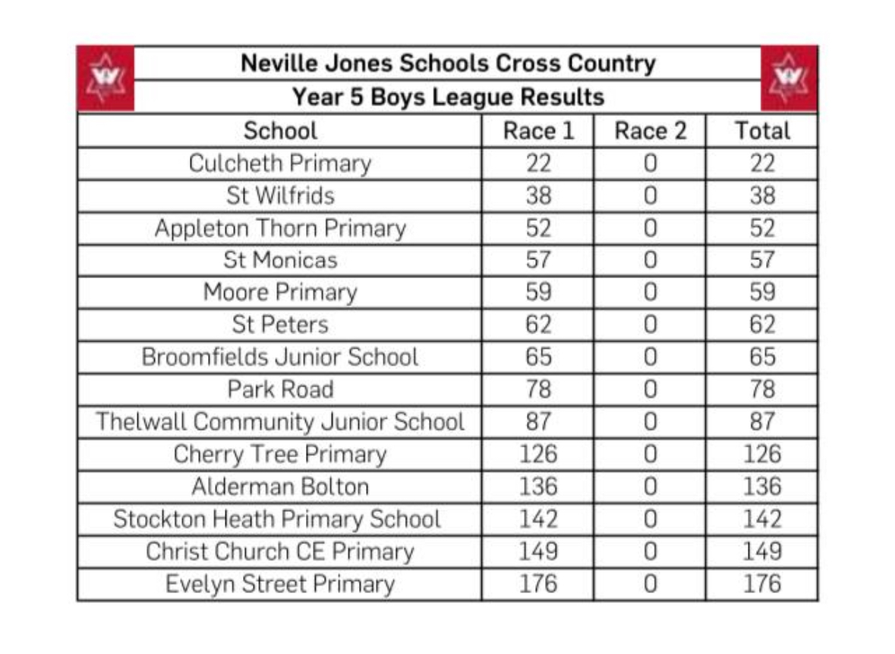

**October**

**Weekly Sports Assembly**

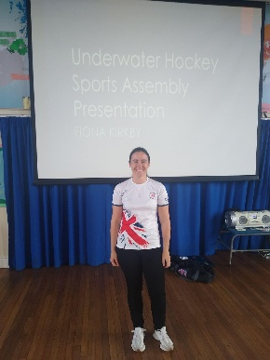**Special Guest- Underwater Hockey Olympic Champion**

**Y5 Girls Football Tournament- Everton Youth Academy**

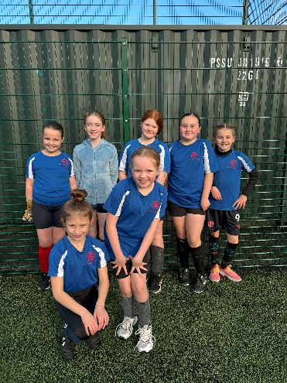

**November**

**December**

**January**

**February**

**March**

**April**

**May**

**June**

**July**