

Culcheth Primary School
Uniform Policy
2025-2026


Adapted from Schools Uniform Policy in Warrington

Date policy last reviewed: | September 2025

Last updated: September 2025

Principles for a school uniform policy
Policies and practice
Warrington Borough Council expects all settings to develop their own school uniform policy, which should incorporate or have regard to best practice. This policy must be consistent with DfE guidance and the Equality Act.
- About the policy:
  - Policy documents should be in line with statutory guidance from the Department for Education on the cost of school uniform.

  - Policy documents should will avoid discrimination in line with our legal duties under the Equality Act 2010 (legislation.gov.uk) which prohibits discrimination against an individual based on the protected characteristics, which include sex, race, religion or belief, and gender reassignment
  - Any policy on school uniform should play a valuable role in contributing to the family and community ethos of our school. Suggested beliefs about uniform include:
- Sets an appropriate, positive tone;
- Promotes a sense of pride in the school;
- Supports positive behaviour and discipline;
- Protects children from social pressures to dress in a particular way;
- Promotes equality between children and their peers;
- Should take account of health and safety issues

- Legal duties under the Equality Act 2010
  - Our school will not discriminate about school uniform. All children should follow the same protocol with regards to uniform requirements.

- Limiting the cost of our school uniform
  - Culcheth Primary School has a duty to make sure that the uniform we require is affordable, in line with statutory guidance from the Department for Education on the cost of school uniform.
  - Culcheth Primary School acknowledges that at times, providing children with a new uniform can be financially difficult. The school will aim to support parents and carers if providing their child with a new uniform is not possible.
  - Ensure that it is available at a reasonable cost
  - Provides the best value for money

To ensure the above the school must indicate ways in which it will provide best value for money:
- Carefully considering whether any items with distinctive characteristics are necessary
- Keeping branded items to a minimum
- Limiting branded items to low-cost or long-lasting items
- Considering how we can maintain the benefits of a branded item whilst keeping costs low, such as logos that can be ironed on
- Avoiding specific requirements for items pupils could wear on non-school days, such as coats, bags and shoes
- Avoid being overly specific with items such as coats, bags and trainers
- Consulting with parents and pupils on any proposed significant changes to the uniform policy

- Our school’s uniform
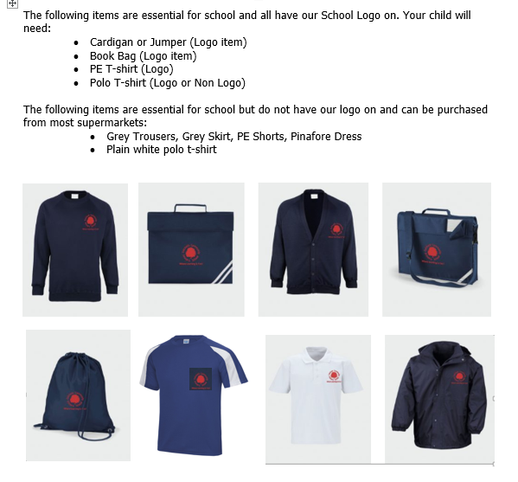
Hairstyle requirements
Natural colours only, no tracks/lines or extreme hairstyles such as mohicans. Long hair must be tied back at all times in school.
- Provision of second-hand uniforms
  - Information about second-hand uniform for example:
- All second-hand uniform donated to school is given to parents as and when needed

- Role of parents and carers
  - Parents and carers are expected to make sure their child has the correct uniform and PE kit, and that every item is clean and in a good condition.

- Governors
  - The governing board will review this policy and make sure that it:
- Is appropriate for our school’s context
- Is implemented fairly across the school
- Offer a uniform that is appropriate, practical and safe for all pupils
- The school does not make a profit from school uniform
  - The board will also make sure that the school’s uniform supplier arrangements give the highest priority to cost and value for money, for example by avoiding single supplier contracts and by re-tendering contracts at least every 5 years.

- Monitoring arrangements
  - This policy will be reviewed in June 2026 by The Full Governing Body

