Culcheth Community Primary School
Charging and Remissions Policy

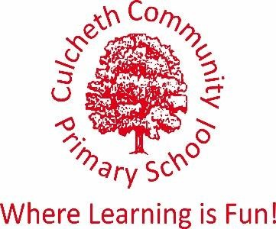

The Education Reform Act 1988 establishes rules for school activities based on the following principles:

- To maintain the right to free school education.
- To ensure that activities offered wholly or mainly during normal teaching time are available to all pupils without charge.
- To give Governing Bodies the discretion to charge for optional extras provided mostly out of school hours.
- To enable schools to invite voluntary contributions from parents.

Free education is defined as that which is required:
- As part of a prescribed examination syllabus
- To fulfil statutory National Curriculum requirements
- To fulfil statutory duties with respect to Religious Education.

All education during school hours is free. We do not charge for any activity undertaken as part of the National Curriculum with the exception of individual or group music tuition which is additional to the curriculum offer.

However, schools have the right to ask for voluntary contributions from parents to assist with the costs. Contributions from parents must be genuinely voluntary. Parents need to be informed that there is no obligation to pay and that children will not be treated differently according to whether or not their parents have made a contribution. Parents will be informed in advance that where insufficient voluntary contributions are raised to fund a visit/activity, it will not be possible for the visit/activity to take place.

Governing Bodies have been authorised to establish a Charging Policy for their school for the following activities:
- Activities taking place wholly or mainly outside school hours as optional extras, such as extracurricular clubs. A small charge will be made for these clubs. Pupil premium children will be offered clubs at no charge.
- Board or lodging for residential visits.
- Materials and ingredients used in practical subjects, only if the parents wish to own the finished article.

B: GUIDELINES

The Governors, Headteacher and staff are of the view that trips and activities are of benefit to the children and that programmes of events should be planned to support the effective implementation of the National Curriculum.

While the Governors endorse the general principle that activities provided wholly or mainly within school time should not be chargeable, they also state that they will invite voluntary contributions from parents when appropriate.

If voluntary contributions for a planned activity are not sufficient to meet the anticipated costs, including insurance, then the activity may be cancelled.

Governors shall give the Headteacher the discretion to subsidise the costs for individuals or groups when necessary.

Wherever practical, the Governors will consider requests from parents in receipt benefits such as Universal Credit to be given full or part remission of any board and lodging costs for children on residential visits.

Governors shall give the Headteacher the discretion to remit charges above this minimum.

The Governors reserve the right to charge for materials and ingredients used in practical or other subjects. This includes water bottles or similar but no intentional profit will be sought.

Written March 2022
Review March 2023

