Maths Curriculum
The Intent
At Culcheth Primary we believe that children should be able to select which mathematical approach is most effective in different scenarios. A typical Maths lesson will provide the opportunity for all children, regardless of their ability and background, to work through Fluency, Reasoning and Problem Solving activities. Pupils are required to explore maths in depth, using mathematical vocabulary to reason and explain their workings. A wide range of mathematical resources are used and pupils are taught to show their workings in a concrete way, before establishing ways of pictorially and formally representing their understanding. They are taught to explain their choice of methods and develop their mathematical reasoning skills. We encourage resilience and acceptance that struggle is often a necessary step in learning. It is paramount that Maths topics are applied to ‘real life’ contexts, in order for the children to have a true purpose for their learning.
National Curriculum Aims
We aim to ensure that all pupils:
- become fluent in the fundamentals of Maths, enabling the children to recall and apply their knowledge rapidly, accurately and independently.
- reason mathematically by following a line of enquiry and explaining their methods with proof and mathematical language.
- can solve problems by applying their maths knowledge to a variety of routine and non-routine problems with increasing perseverance in seeking the solutions.
Implementation
We implement our approach through high quality teaching delivering appropriately challenging work for all individuals with age appropriate independence. In Key Stage 2 all classes are split according to register order, half the class is taught by the class teacher, while the other half is taught by the maths co-ordinator. The whole school is using ‘Power Maths’, with Years 1, 2 and 3 each having an individual maths practice book to work through. Daily Maths sessions of 50 minutes makes the lessons pacey and keeps everyone on task. Each lessons starts with an aspect of counting followed by a hook. The hook is normally a problem, this enables the teacher to see any gaps in the children’s learning and address them appropriately. As well as ‘Power Maths’ we use a range of planning resources including: White Rose Hubs, NCETM, Busy Ants and NRICH. All teachers endeavor to plan lessons which co-inside with the school motto “Where Learning is Fun!”, this is evident across the year groups.

We use ‘The mastery approach’ which explores and demonstrate mathematical ideas, to enrich their learning experience and deepen understanding. These elements help cement knowledge so pupils truly understand what they’ve learnt. Children use problem solving skills which match the aims of the appropriate year group curriculum, and these challenges are coherently planned and sequenced through the terms and years in order for the children to build and acquire sufficient knowledge.
All pupils, when exposed to a key new concept, should have the opportunity to build competency in this topic by taking this approach. Pupils are encouraged to physically represent mathematical concepts. Objects and pictures are used to demonstrate and visualise abstract ideas, alongside numbers and symbols.
We aim to create an environment which is tailored to the needs of the children, we carefully select teaching materials that clearly support the lessons objectives.
Concrete – children have the opportunity to use concrete objects and manipulatives to help them understand and explain what they are doing.
Pictorial – children then build on this concrete approach by using pictorial representations, which can then be used to reason and solve problems.
Abstract – With the foundations firmly laid, children can move to an abstract approach using numbers and key concepts with confidence.

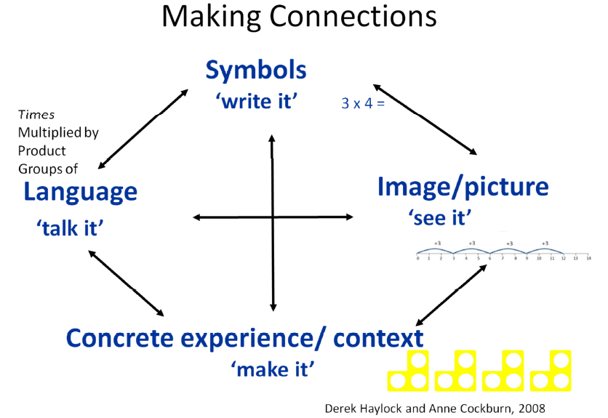

It is vital that children are continually revisiting past topics, so that their learning is not lost. Our online Maths homework, ‘Maths Whizz’ (Years 2-6) caters to every child’s individual needs, revisits topics and improves their pace of learning. Maths Whizz creates an instant assessment tool, which shows misconceptions across areas from different programmes of study, teachers can access this easily and give appropriate feedback. Daily morning activity tasks enables teachers to focus on topics that are not being taught that half term. This daily review and practice helps to keep topics fresh in their minds.

Impact
Through our teaching we continuously monitor pupils’ progress against expected attainment for their age, making formative assessment notes where appropriate and using these to inform our discussions in termly Pupil Progress Meetings. The main purpose of all assessment is to always ensure that we are providing excellent provision for every child. We are piloting a new assessment tool this year from ‘Power Maths’. This aims to address gaps quickly and effectively for all pupils, which will in turn inform teaching.

The impact our mathematical philosophy for teaching and learning is having can be seen across the school:

At Expected in Maths
Year 1 |  | Year 2 |  | Year 3 |  | Year 4 |  | Year 5 |  | Year 6
Summer 2018 | Summer 2019 | Summer 2018 | Summer 2019 | Summer 2018 | Summer 2019 | Summer 2018 | Summer 2019 | Summer 2018 | Summer 2019 | Summer 2018 | Summer 2019
100% | 93% | 90% | 90% | 50% | 97% | 92% | 89% | 96% | 90% | 97% | 97%

At Greater Depth in Maths
Year 1 |  | Year 2 |  | Year 3 |  | Year 4 |  | Year 5 |  | Year 6
Summer 2018 | Summer 2019 | Summer 2018 | Summer 2019 | Summer 2018 | Summer 2019 | Summer 2018 | Summer 2019 | Summer 2018 | Summer 2019 | Summer 2018 | Summer 2019
78% | 40% | 48% | 26% | 13% | 32% | 35% | 59% | 44% | 40% | 41% | 25%

